D3 is capable of doing many stuffs which directly modify the DOM tree such as appending or deleting element, changing element states and attributes.
var vs = [ "From East", "to West,", "at Home", "is Best" ];
d3.select( "body" )
.append( "ul" ).selectAll( "li" )
.data(vs).enter()
.append("li").text( d => d );
D3 also support us some simple animation with the help of its built-in animation API.
function makeList() {
var vs = [ "From East", "to West,", "at Home", "is Best" ];
d3.select( "body" )
.append( "ul" ).selectAll( "li" )
.data(vs).enter()
.append("li").text( d => d )
.on( "click", function () {
this.toggleState = !this.toggleState;
d3.select( this )
.transition().duration(2000)
.style("color", this.toggleState?"red":"black");
} );
}
Important knowledge about D3
D3 is a JavaScript library for manipulating the DOM tree in order to represent information visually.
Three common tasks when working with D3.
- Select an element or DOM node In DOM tree to perform any data visualization
- Binding data set to associated DOM node.
- Change size, position or appearance of that DOM node to match the value of data.

Select
d3.select(selector)
d3.selectAll(selector) return the ordered list of elements which match the selector pattern.
select can be changed
bs = d3.selectAll( "p" ).select( "b" );
will select the first bold element in all paragraphs in the document:

binding data
The data() method accepts an array of arbitrary values or objects and attempts to establish a one-to-one correspondence between the entries of this array and the elements in the current selection.
If a data point has been associated with a DOM element, the data point itself is stored in the __data__ property of the selection element.
After a call to data(data), collections of any unmatched items are
accessible through the enter() and exit() methods
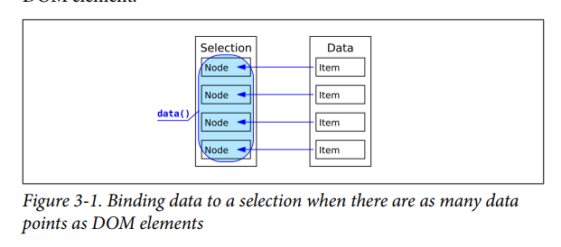
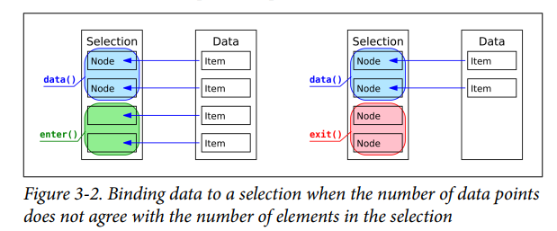
Manipulate element
sel.attr(name, value) Sets the attribute named name to the supplied value.
Sel.attr (name,function)
function( d, i, nodes ) {
this === nodes[i]; // true!
}
where d bound to the current element , element’s index i in the
current selection ,array nodes containing the nodes in the
current selection
sel.style(name, value, priority) : Sets the named style property to the supplied value. An override priority may be specified by supplying the string "important" (without exclamation point) as the third parameter. Note that style length properties usually require units (in contrast to SVG attributes).

sel.classed(value, flag): The value argument should be a whitespace separated string of class names. If the flag parameter evaluates to true, the class attribute is set to this string; if flag evaluates to false, the classes are unassigned.
sel.text(value) Sets the “text content” to the supplied value: use this to set the actual text for <text> elements. (This method replicates a corresponding property on the DOM Node interface.)
sel.html(value) Sets the “inner HTML” to the supplied value: this is the HTML with its markup inside of, but not including, the current element. (This method replicates a corresponding property on the DOM Element interface.)
sel.datum(value) Sets the data bound to this element to the supplied value.
All function arguments are optional (as always in JavaScript). The functions in Table 3-4 can be used to set, get, or clear an attribute (or property,5 or style, …), depending on the value argument:
• If no value is supplied, the function returns the current value for the first nonnull element in the selection.
• If a null value is supplied, the attribute (or property) is removed from the element.
• If a constant value is supplied and not null, the attribute (or property) is set to the supplied value.
• If a function is supplied, it is evaluated for every element in the selection and its return value is used to modify the current element.

The Selection abstraction provides several functions to operate on the entire selection, for example, to add, remove, or reorder elements .
sel.insert(item,before) Inserts an element before the first element matching the before selector for each element in the current selection.
sel.append(item) Appends an additional element to each element in the current selection.
sel.remove() Removes the selected elements from the document and returns a selection containing the removed elements
sel.sort(comparator) Takes a function of two arguments (a and b), which is called with the data bound to the elements of this selection. The comparator should return -1 if a is less than b, +1 if b is less than a, and zero otherwise. Returns a new selection with each group sorted according to the comparator; also reinserts elements into the current selection accordingly. When no comparator is supplied, the selection is sorted in ascending order.

Event handling
D3 has its api as the abstraction for register event handler
To register an event callback
sel.on( type, callback )
type is string representing the vent such as click

graphical building blocks provided by D3

